**Flasketball Bug Hunt!**

**PURPOSE:**

* To recognize common bugs that happen while building Flask apps.
* To be comfortable navigating an unfamiliar codebase.
* To employ methodical strategies for finding the specific code causing it and testing your assumptions.
* To solve for bugs by testing potential fixes appropriately one line at a time.

**GOAL:** Get your team to fix as many bugs as you can before time runs out!

**ACHIEVEMENTS:**

* Group with a creative fix or an extra improvement → Some extra bragging rights
* Group with most bugs fixed OR who finishes first → Super bragging rights
* Group that finishes the Ninja Bonus → Ultra bragging rights.

**DIRECTIONS:**

Come up with a team name, then complete the following tasks to make the app work. For each bug, one person should “drive”, that is, share their screen as you all contribute to hunting the bug down. Everyone can help “navigate”. Switch drivers throughout so every team member has a chance to drive. Also assign a note-taker and a group representative.

**THE HUNT**

1. **Note-taker: Make an empty document** to keep the screenshots and document how you fixed the bug
2. **Find and fix** the first bug(s): Open and run the broken Flasketball app. Try to submit the form on the first page. Fix any bugs until you are able to get to the dashboard page.

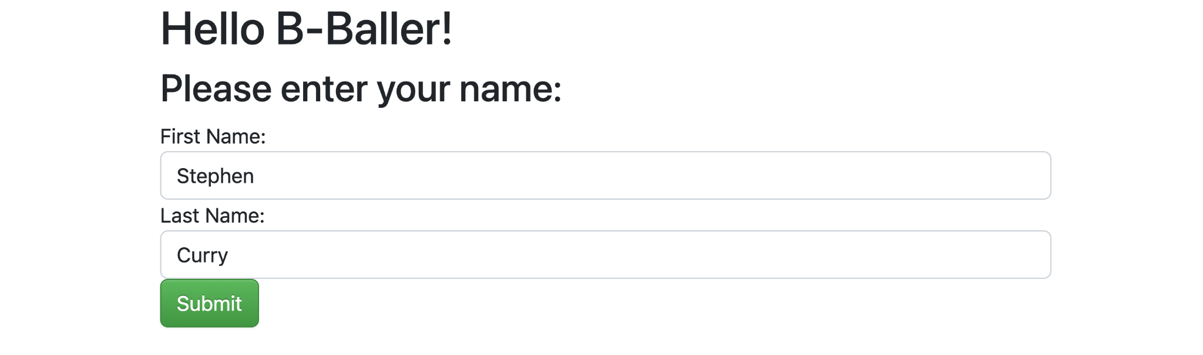

1. **Test the ‘Ranking’ feature**. Fill out the form with a name or names to test the functionality. Work through any errors until the names appear on the ranking board.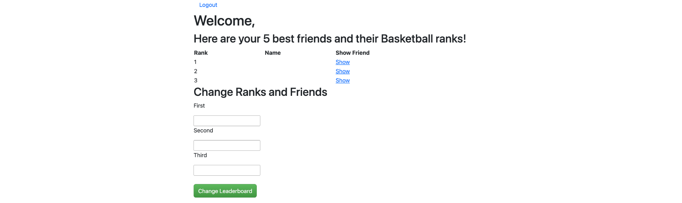
2. **Test the “show” feature.** Press each of the show links to see if they are working.

***Hint:*** *once you follow the codeflow to where you think the problem might be, before changing anything try print statements to test or assert your assumptions.*

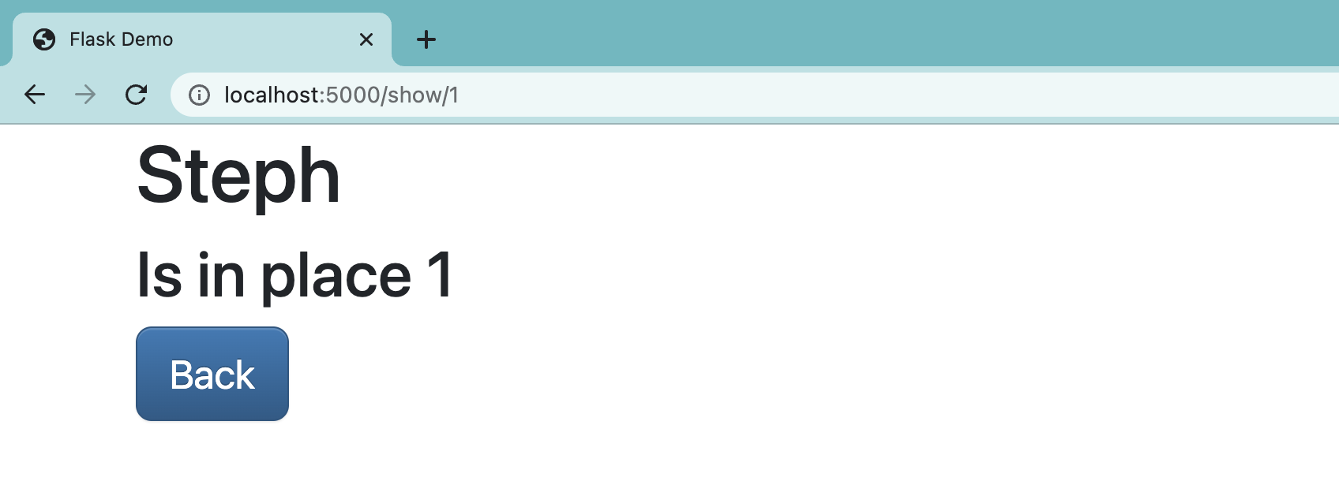

1. ***NINJA BONUS:*** *Alter the code so that when someone submits a form with any empty fields, it doesn’t replace the name of that rank with a blank.*
2. **Submit your Bug Sheet** - **Upload it on Discord** in our cohort channel with your team name and the team members. (Only 1 person needs to do this).